Dis-Indo-Borneo-Dayak- Hudok Mask

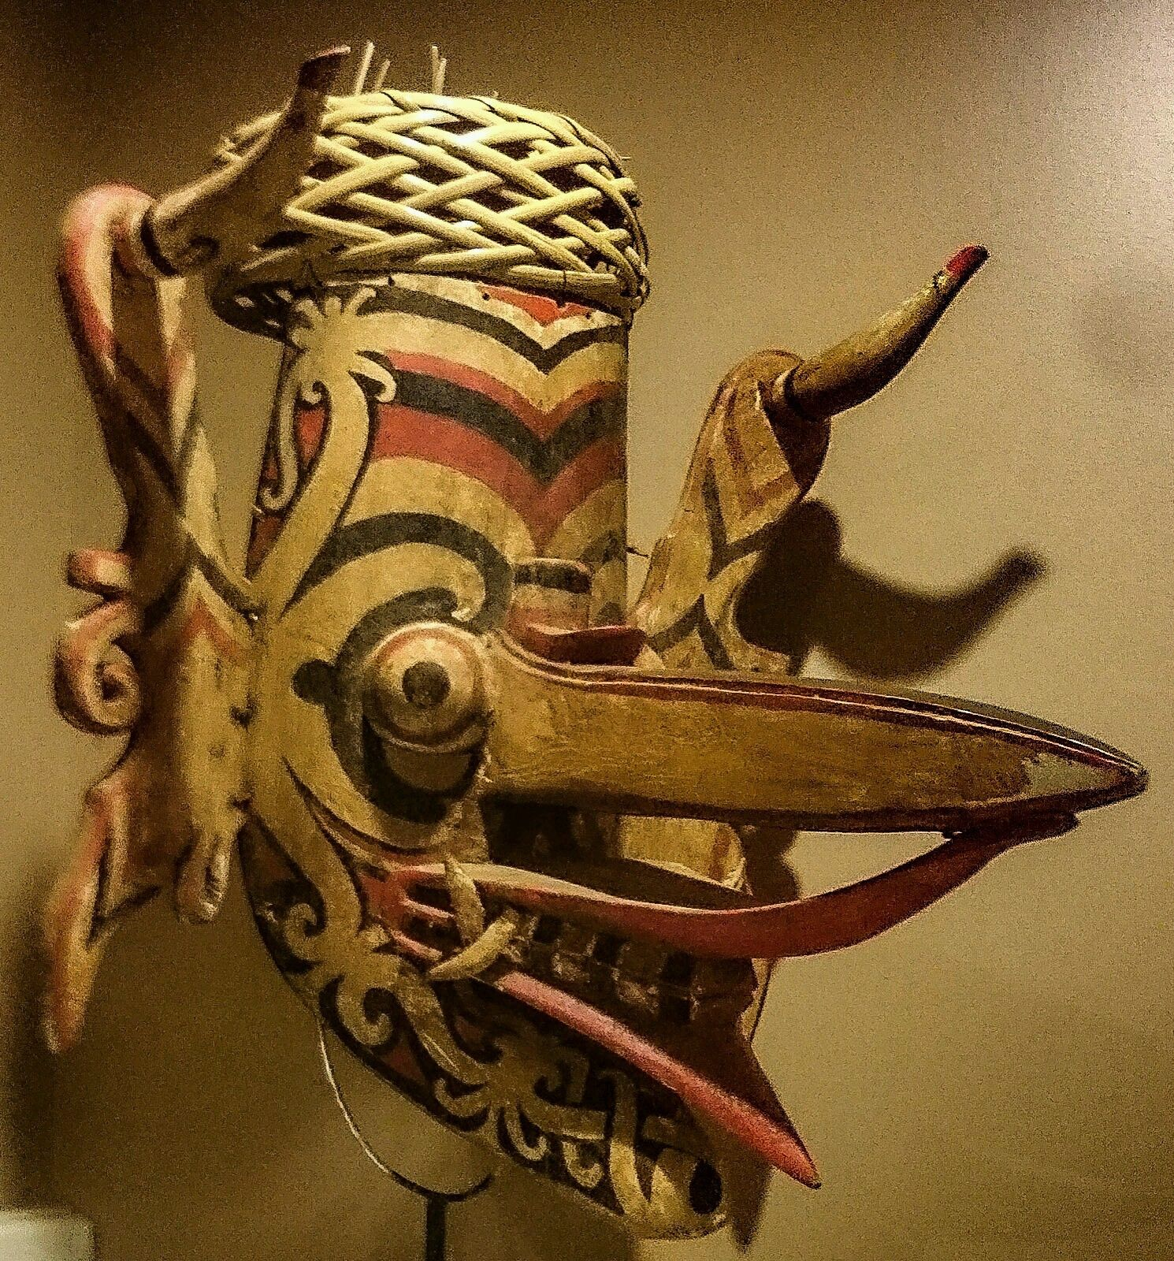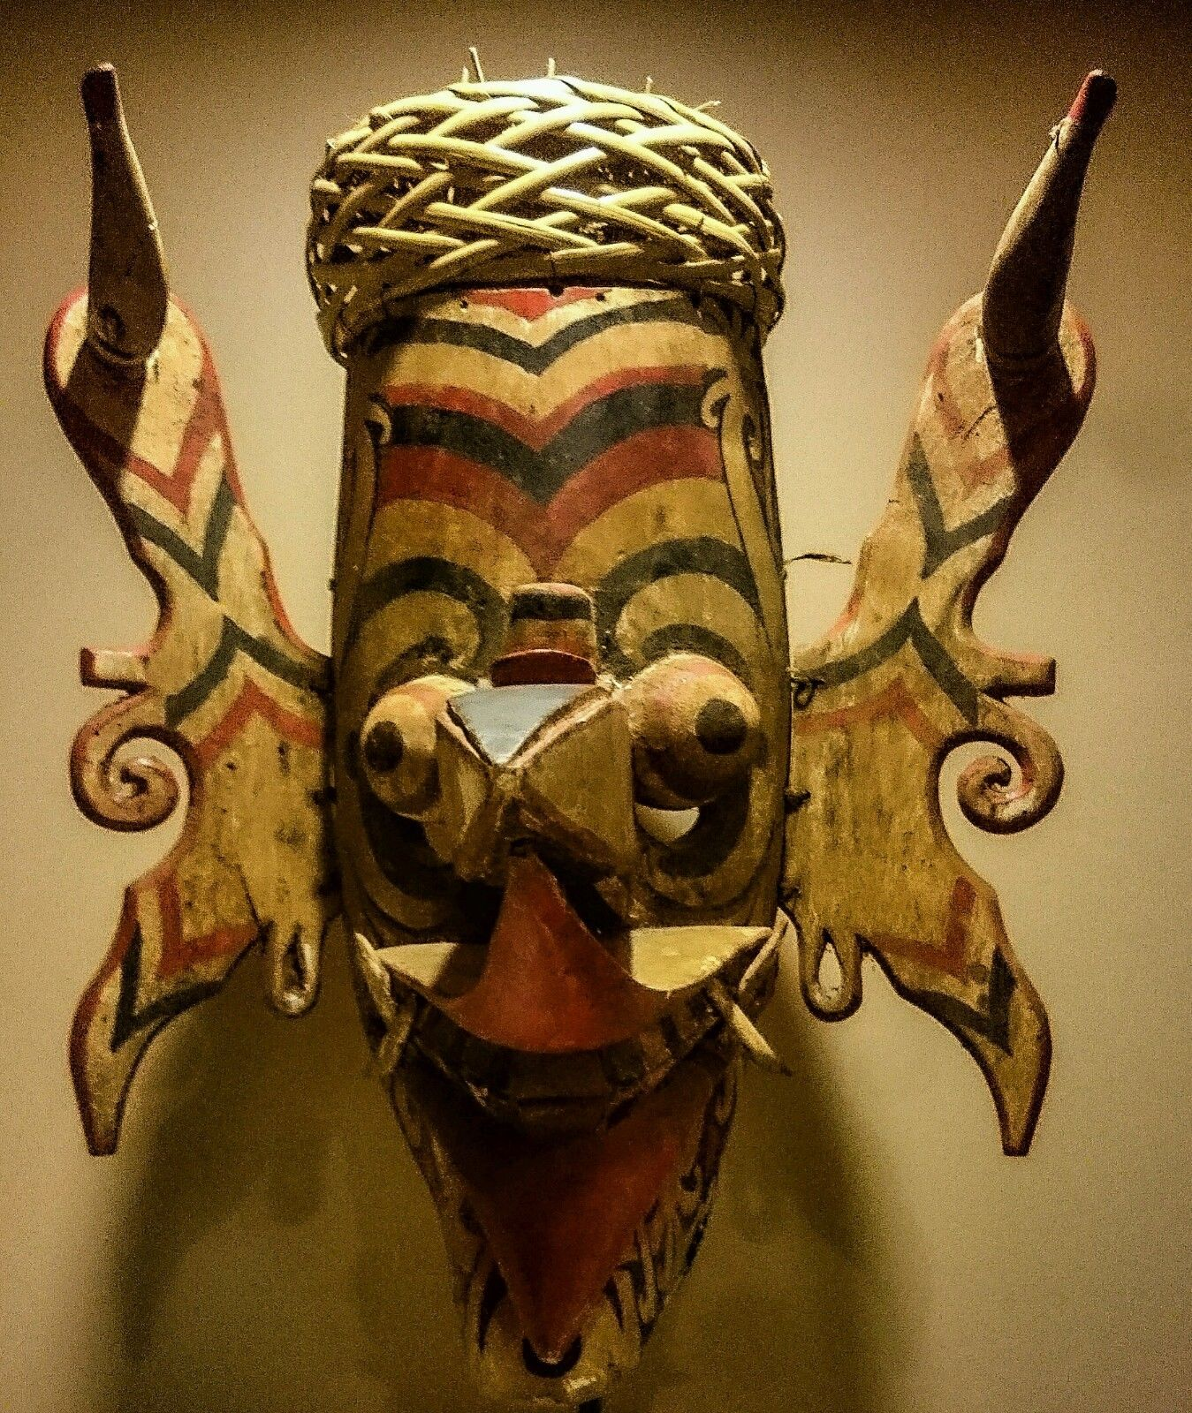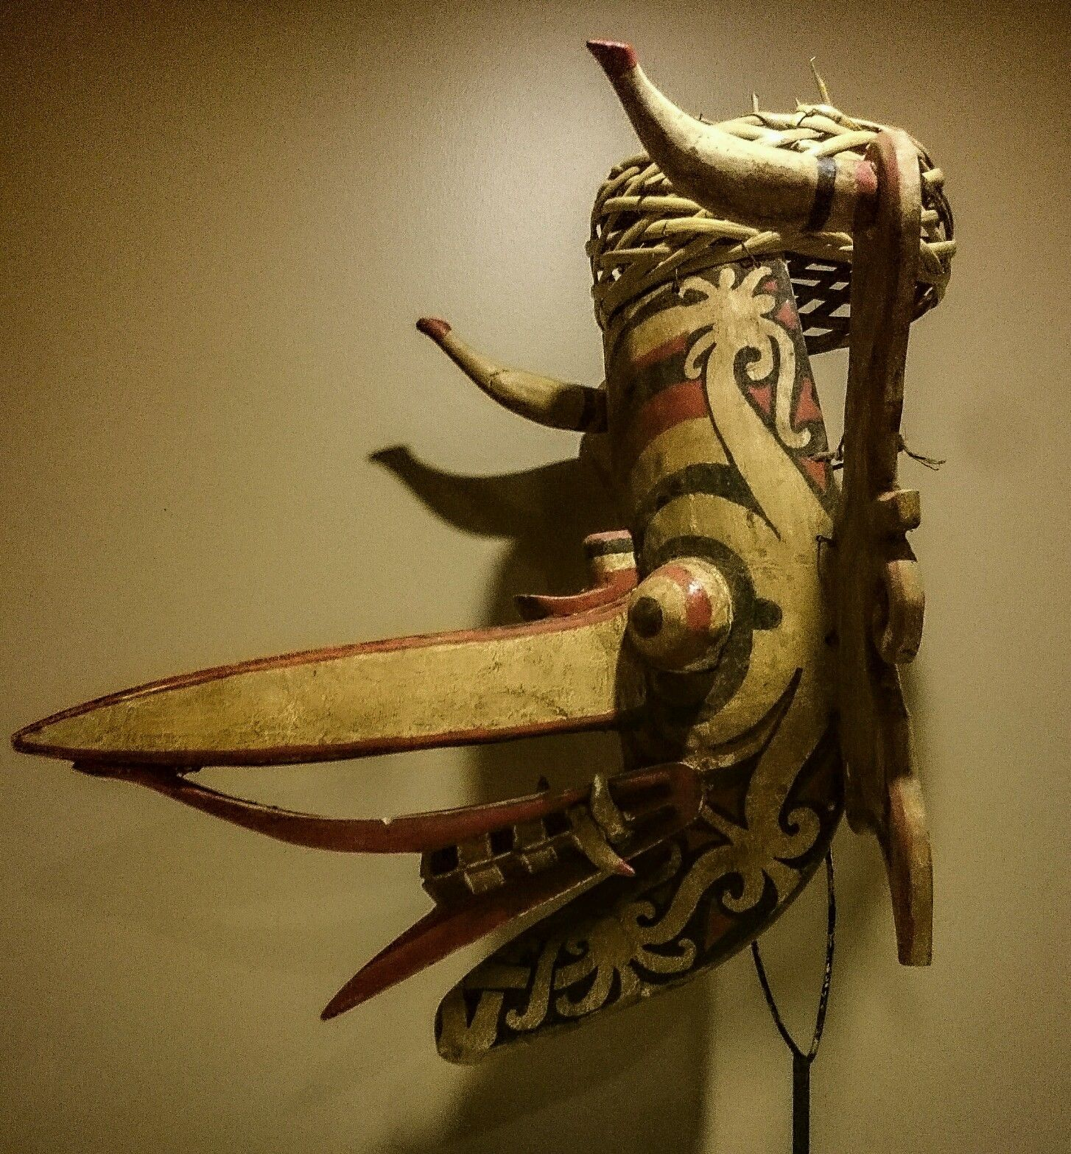

Fig. 1. Borneo, Bahau Dayak People, Dragon-hornbill *Hudoq* Mask, ca 1930

Formal Label: Borneo, Bahau Dayak People, Dragon-hornbill *Hudoq* Mask, ca 1930

Accession Number:

**LC Classification:** DS646.

Date or Time Horizon: 1930

Geographical Area: Borneo, Makaham River

Map:

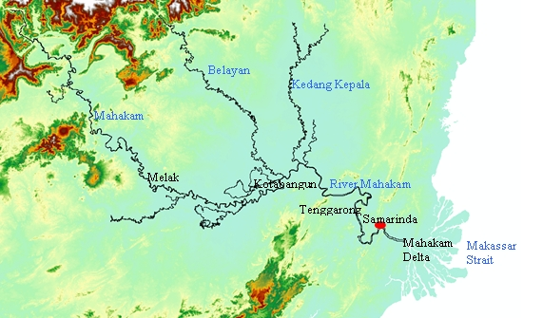

Fig. 2. Map of Mahakam River after [Hidayat008](https://commons.wikimedia.org/wiki/User:Hidayat008) https://upload.wikimedia.org/wikipedia/commons/e/ea/MahakamMap.jpg.

Cultural Affiliation: Dayak

Media: Polychrome (Red, Black and White) Pigments, Wood, Rattan.

Dimensions: H 43cm ; W 38cm.  
Weight:

Condition: The example here is in an excellent, stable condition with no losses or repairs. It has a patina consistent with an early twentieth century dating.

Provenance: private collection, UK.

**Discussion:** This mask is from a Dayak Bahau *kampung* (village), on the upper Mahakam River region of Borneo.It is of light wood and represents a composite dragon-hornbill spirit. It would have been worn by a dancer at planting, harvest and similar festivals. Young male dancers wearing such masks and cloaks enter the village at critical times connected with the rice growing cycle and impersonate the spirits who have come down to earth to bless the harvest, a ritual known as *Hudoq*. Apertures just below the mask's 'eyes' allowed the dancer to see.

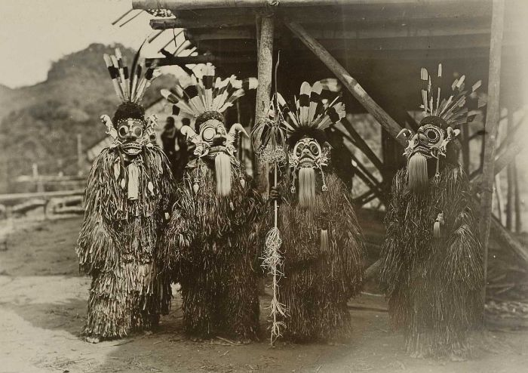Fig 3. A group of *Hudoq* dancers by J. (Jean) Demmeni, photographer, during the Mask dance sowing celebration of the Bahau Dayaks, Upper Mahakam River Region. This picture was taken during the Commission's Trip to Central Borneo A. W. Nieuwenhuis, 1898-1900. From the Tropenmuseum in Amsterdam, part of the National Museum of World Cultures, CC BY-SA 3.0, https://commons.wikimedia.org/w/index.php?curid=8595445

This mask comprises the central head element, ears attached by means of rattan ties, and a a woven rattan basket cap. Related examples are illustrated in Barbier (1984, p. 80), Maxwell (2010, p. 89), Hardianti & ter Keurs (2005, p. 99), Miksic (2007, p. 226), Capistrano-Baker (1994, p. 32), and Meulenbeld *et al* (1988, p. 125). The mask is painted in cream, red and black polychrome. The mask has a protruding mouth from which two sets of fangs project. The eyes are semi-spherical and bulging with black pupils. And the prominent beak juts out almost horizontally. The lips are exaggerated and protrude over the teeth.  
 The mask was worn by fitting the basket cap with hornbill feathers (which are not present because they are illegal to export) over the dancer's head allowing the mask to hang over the dancer's face. Masks in museum collections often no longer retain their woven rattan caps, unlike this example, which shows it has actually been used in *Hudoq* dances. In the dance "The young men are completely transformed into hairy creatures with fiber cloaks, with large eyes, gigantic fangs, and huge ears ornamented with tiger-cat tusks appropriate for a spectacle depicting the frightful aspect of these powerful spirits" (Nieuwenhuis 1904: 325). The dazzling and incredible profiles of masks like the one here sprout great snouts and fabulous ears and piercing demon eyes to produce a supreme spectacle of wonder and amazement.

Yet, there is another side to this Hudoq dance: a benevolent function of soul-catching. Sarah Gill (1967) has offered the suggestion that these dances originated in South-east Asia, and indeed, there, too, the rice plant was believed to be animated by a spirit or soul. This parallels the belief system behind the *Hudoq* dances in Borneo. Furthermore, these Bahau Dayaks of the Upper Mahakam River Region speak an Austronesian language and, therefore, represent one of the [Austronesian](https://en.wikipedia.org/wiki/Austronesian_people) [ethnic groups](https://en.wikipedia.org/wiki/Ethnic_group) of [Maritime Southeast Asia](https://en.wikipedia.org/wiki/Maritime_Southeast_Asia) with their origins from the southern [Philippines](https://en.wikipedia.org/wiki/Philippines). Should the soul be lost the rice would die: so these same fabulously masked *Hudoq* dancers clad in their hairy cloaks enter the rice paddies behind their leader who, with his *krawit bruwa* or soul-catching hook, seeks lost rice spirits and with his hook snares them from oblivion (Nieuwenhuis 1904: 32).

***References****:*Barbier, J.P. 1984. *Indonesian Primitive Art.* Dallas: Dallas Museum of Art.  
Capistrano-Baker, F.H. 1994. *Art of Island Southeast Asia: The Fred and Rita Richman Collection in the Metropolitan Museum of Art*. New York: The Metropolitan Museum of Art.

# Gill , Sarah. 1967. "Style and the Demonic Image in Dayak Masks," **Journal of the Malaysian Branch of the Royal Asiatic Society**, 40(1): 78-92.

Hardianti, E.S. & P. ter Keurs, eds. 2005. *Indonesia: The Discovery of the Past*. Amsterdam: KIT Publishers for De Nieuwe Kerk.

Kemkens,Lotte. 2011. Living on Boundaries: The Orang Bajo of Tinakin Laut, Indonesia (PDF) (Social Anthropology BA thesis). University of Utrecht*.* dspace.library.uu.nl/bitstream/handle/1874/.../Kemkens%20Lotte.pdf?... *Retrieved 16 Feb. 2017*.Maxwell, R. 2010. *Life, Death & Magic: 2000 Years of Southeast Asian Ancestral Art*. Sidney: National Gallery of Australia.  
Meulenbeld, B.C., *et alii*. 1988. *Budaya Indonesia: Arts and Crafts in Indonesia. Am*sterdam: Tropenmuseum.  
Miksic, J. 2007. *Icons of Art: The Collections of the National Museum of Indonesia*.  [Menteng, Jakarta]:  BAB Publishing.

# Nieuwenhuis**, A. W. 1904.** *Quer durch Borneo. Ergebnisse seiner Reisen in den Jahren 1894, 1896-97 und 1898-1900 von Dr. A.W. Nieuwenhuis. Unter Mitarbeit von Dr. M. Nieuwenhuis-von Üxküll-Güldenbandt.* Leiden: Brill.

Sellato, B., ed. 2012. *Plaited Arts from the Borneo Rainforest*. N.p.: NIAS Press.